1.

Some of the main features of HTML5 are as follows -

Improved Multimedia support - HTML5 allows for the integration of multimedia elements such as audio and

video directly into web pages without the need for plugins like Flash.

Canvas element - HTML5 introduced the <canvas> element, which allows for dynamic, interactive graphics to

be created and manipulated within a web page.

Geolocation API - HTML5 provides an API for obtaining the user's location, enabling web applications to offer

location-based services.

Local Storage - HTML5 introduced the localStorage API, which allows for the storage of data on the user's

device, improving performance and reducing the need for round-trips to the server.

New Structural Elements - HTML5 introduced new semantic elements such as <header>, <footer>, <nav>, and

<article> that makes it easier to structure and organize content on a web page.

Form Improvements - HTML5 introduced several improvements to forms, including new input types like date,

time, and color, as well as new attributes such as required and autofocus.

Accessibility improvements - HTML5 provides better support for accessibility, including the ability to provide

alternative text for images and improved support for screen readers.

2.

**HTML Entities:**

HTML entities are special codes that represent reserved characters, symbols, or characters with specific

meanings in HTML. They are used to display characters that might otherwise be interpreted as HTML code or

cause rendering issues in web browsers. HTML entities are written using an ampersand (&) followed by a

specific code or name, and ending with a semicolon (;).

**5 Commonly Used HTML Entities:**

**&lt; - Represents the less-than symbol <.**

Example: <p>This is an example &lt;em&gt;text&lt;/em&gt;.</p>

**&gt; - Represents the greater-than symbol >.**

Example: <p>For more information, visit our website &gt; <a href="#">here</a>.</p>

**&amp; - Represents the ampersand symbol &.**

Example: <p>For further details, contact us &amp; we'll assist you.</p>

**&quot; - Represents a double quotation mark "**

Example: <p>The title of the book is "The Great Gatsby".</p>

**&copy; - Represents the copyright symbol ©.**

Example: <p>&copy; 2023 ACME Corporation. All rights reserved.</p>

3.

Accessibility in Web Development: Accessibility in web development refers to designing and coding websites

in a way that ensures people with disabilities can perceive, understand, navigate, and interact with digital

content effectively. It involves making web content inclusive and usable for everyone, regardless of their

abilities.

Importance of Accessible Websites:

Inclusivity: Accessible websites ensure that everyone, including people with disabilities, can access and use

online information and services.

0egal Compliance: Many countries have laws requiring websites to be accessible, avoiding legal issues and

promoting equal access.

User Experience: Accessible design often leads to improved user experiences for everyone, including clear

navigation and content structure.

Business Growth: Accessible websites reach a wider audience, increasing engagement, loyalty, and potential

customer base.

Benefits for User Groups:

(isual Impairments: Accessibility provides screen reader support and text alternatives, aiding blind and

visually impaired users.

Hearing Impairments: Captions and transcripts benefit those with hearing impairments by making audio

content understandable.

Motor Disabilities: Keyboard navigation and easy-to-click elements assist users with motor limitations.

Cognitive Disabilities: Accessible design simplifies content and layout, aiding individuals with cognitive

challenges.

Elderly Users: Accessible websites accommodate age-related limitations, ensuring usability for elderly users.

Mobile Users: Accessible design improves mobile experiences through simplified and responsive layouts.

4.

**Use Semantic HTM0 Elements**: Using semantic HTML elements helps improve accessibility by providing

meaningful structure to your content. Semantic elements like <header>, <nav>, <main>, <article>, and <footer>

convey the purpose of different sections to assistive technologies, making it easier for users with disabilities to

navigate and understand the content.

**Provide Alt Text for Images**: Adding descriptive alt text to images using the alt attribute ensures that users who

cannot see the images can understand their content and purpose. Screen readers read aloud the alt text,

making visual content accessible to people with visual impairments. Aim to make alt text concise, informative,

and relevant to the image.

**Use Color with Care**: Color plays an important role in web design, but it should not be the only means of

conveying information. Ensure that color is not the sole indicator of meaning. For example, when using error

messages, pair color with text that explains the error. Additionally, maintain sufficient color contrast between

text and background to enhance readability for users with low vision.

5.

<!DOCTYPE html>

<html lang="en">

<head>

<meta charset="UTF-8" />

<meta name="viewport" content="width=device-width, initial-scale=1.0" />

<title>HTML5 Features Showcase</title>

</head>

<body>

<header>

<h1>HTML5 Features Showcase</h1>

<p>Welcome to our beginner-friendly webpage showcasing HTML5 features.</p>

</header>

<section>

<h2>Feature 1: Video Playback</h2>

<p>

HTML5 introduced the <code>&lt;video&gt;</code> element for embedding

videos directly in web pages.

</p>

<video width="400" controls>

<source src="sample-video.mp4" type="video/mp4" />

Your browser does not support the video tag.

</video>

</section>

<section>

<h2>Feature 2: Form Validation</h2>

<p>

HTML5 offers built-in form validation, reducing the need for custom

JavaScript code.

</p>

<form>

<label for="email">Email:</label>

<input type="email" id="email" required />

<br />

<input type="submit" value="Submit" />

</form>

</section>

<section>

<h2>Feature 3: Semantic Tags</h2>

<p>

HTML5 introduced semantic tags like <code>&lt;header&gt;</code>,

<code>&lt;nav&gt;</code>, <code>&lt;main&gt;</code>, and more, which

improve page structure and accessibility.

</p>

<article>

<h3>Article Title</h3>

<p>

This is a sample article content. Semantic tags make it easier to

structure your content and improve search engine optimization.

</p>

</article>

</section>

<footer>

<p>Created by Your Name &copy; 2023</p>

</footer>

</body>

</html>

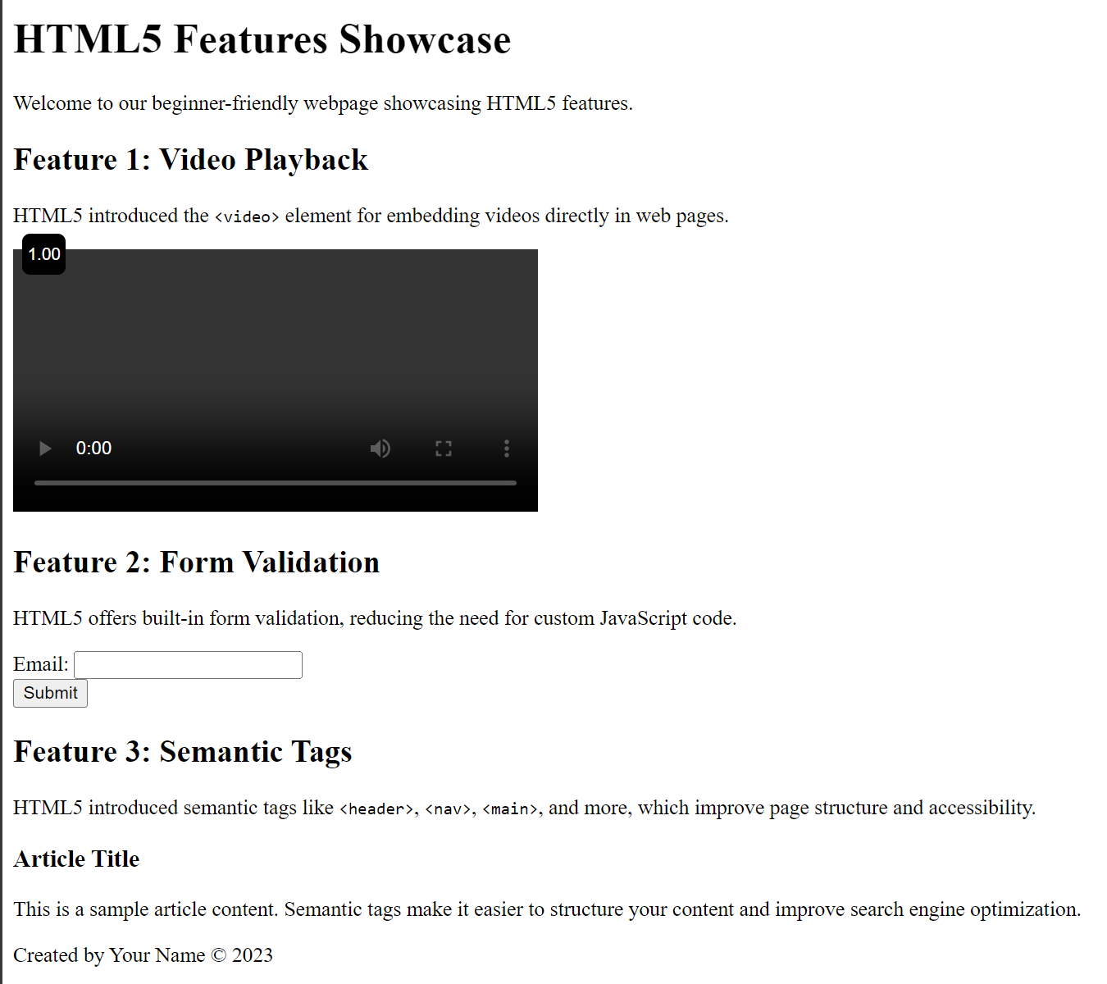

6.

<!DOCTYPE html>

<html lang="en">

<head>

<meta charset="UTF-8" />

<meta http-equiv="X-UA-Compatible" content="IE=edge" />

<meta name="viewport" content="width=device-width, initial-scale=1.0" />

<title>HTML v/s HTML5</title>

</head>

<body>

<h1>HTML v/s HTML5</h1>

<table border="1">

<thead>

<tr>

<th>HTML</th>

<th>HTML5</th>

</tr>

</thead>

<tbody>

<tr>

<td>

It required plugins like Adobe Flash to support audio and video

content.

</td>

<td>

Provides built-in support for multimedia elements such as video and

audio without the need for a plugin.

</td>

</tr>

<tr>

<td>It has fewer elements as compared to HTML5.</td>

<td>

It includes new elements and form attributes such as time, date, and

colour. Required and autofocus in input types of the tag element as

well.

</td>

</tr>

<tr>

<td>It does not have support for local storage.</td>

<td>It has support for local storage i.e. localStorage.</td>

</tr>

<tr>

<td>

Less semantic elements, thereby providing less web accessibility

features.

</td>

<td>

<p>

It supports more semantic elements, such as &lt;header&gt;,

&lt;footer&gt;, &lt;nav&gt;, and &lt;article&gt;, thereby

improving accessibility.

</p>

</td>

</tr>

</tbody>

</table>

</body>

</html>

